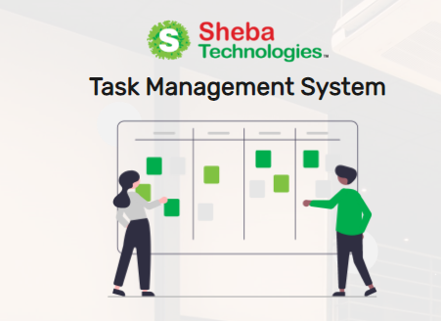

**Task Management System (TMS)**

***Application User Manual***

Document Version 1.0

07 November 2021

**Disclaimer**

This guide has been validated and reviewed for accuracy. The instructions and descriptions it contains are accurate for Task Management System application. However, succeeding versions and guides are subject to change without notice.

**Revision History**

|  |  |  |  |
| --- | --- | --- | --- |
| **Revision No.** | **Created/Updated By** | **Release Date** | **Comments** |
| 1.0 | A S M Lutful Kabir | 09 November 2021 | 1st Release |

**Table of Contents**

[1 About the Solution 6](#_Toc87539985)

[2 Purpose of this Guide 6](#_Toc87539986)

[3 Typographical Conventions 6](#_Toc87539987)

[4 Application Channel 6](#_Toc87539988)

[5 Login 7](#_Toc87539989)

[5.1 User Login 7](#_Toc87539990)

[5.2 Invalid Email / Password 8](#_Toc87539991)

[5.2.1 Forget Password 8](#_Toc87539992)

[6 Navigation Bar 9](#_Toc87539993)

[7 Dashboard 11](#_Toc87539994)

[7.1 Assign New Task 13](#_Toc87539995)

[7.1.1 Create New Task (Assigner Module) 14](#_Toc87539996)

[7.1.2 Accept New Task (Assignee Module) 18](#_Toc87539997)

[8 Task Analytics 20](#_Toc87539998)

[8.1 Overall Task Status 20](#_Toc87539999)

[8.2 Program Wise Details 21](#_Toc87540000)

[8.2.1 Overdue Task Status 21](#_Toc87540001)

[8.2.2 Overall Task Status 22](#_Toc87540002)

[8.2.3 Programme Task Details 22](#_Toc87540003)

[9 User Management 23](#_Toc87540004)

[9.1 All User List 23](#_Toc87540005)

[9.2 Add New User 24](#_Toc87540006)

[9.3 Edit User 26](#_Toc87540007)

[9.4 Bulk Upload 27](#_Toc87540008)

[10 Role Management 28](#_Toc87540009)

[10.1 All Role List 28](#_Toc87540010)

[10.2 Create Role 29](#_Toc87540011)

[10.3 Edit Role 30](#_Toc87540012)

[11 Report 31](#_Toc87540013)

[12 Notification Module 32](#_Toc87540014)

**List of Figures**

[Figure 1 Login Page 7](file:///C:\Users\Sheba\OneDrive\Desktop\TMS_User_Manual_%20V-1.docx#_Toc87539848)

[Figure 2 Invalid Login 8](file:///C:\Users\Sheba\OneDrive\Desktop\TMS_User_Manual_%20V-1.docx#_Toc87539849)

[Figure 3 Reset Password Page 8](file:///C:\Users\Sheba\OneDrive\Desktop\TMS_User_Manual_%20V-1.docx#_Toc87539850)

[Figure 4 Navigation bar 9](#_Toc87539851)

[Figure 5 User Dashboard 11](file:///C:\Users\Sheba\OneDrive\Desktop\TMS_User_Manual_%20V-1.docx#_Toc87539852)

[Figure 6 Assign a New Task 13](file:///C:\Users\Sheba\OneDrive\Desktop\TMS_User_Manual_%20V-1.docx#_Toc87539853)

[Figure 7 New Task Create 16](file:///C:\Users\Sheba\OneDrive\Desktop\TMS_User_Manual_%20V-1.docx#_Toc87539854)

[Figure 8 New Task Details Page 16](file:///C:\Users\Sheba\OneDrive\Desktop\TMS_User_Manual_%20V-1.docx#_Toc87539855)

[Figure 9 All Task List (Assignee Module) 18](file:///C:\Users\Sheba\OneDrive\Desktop\TMS_User_Manual_%20V-1.docx#_Toc87539856)

[Figure 10 Update Task Status 18](file:///C:\Users\Sheba\OneDrive\Desktop\TMS_User_Manual_%20V-1.docx#_Toc87539857)

[Figure 12 Request Menu 19](file:///C:\Users\Sheba\OneDrive\Desktop\TMS_User_Manual_%20V-1.docx#_Toc87539858)

[Figure 13 Overall Task Status Panel 20](file:///C:\Users\Sheba\OneDrive\Desktop\TMS_User_Manual_%20V-1.docx#_Toc87539859)

[Figure 14 Individual Task Details 20](#_Toc87539860)

[Figure 15 Program Wise Details 21](file:///C:\Users\Sheba\OneDrive\Desktop\TMS_User_Manual_%20V-1.docx#_Toc87539861)

[Figure 16 Overdue Task Statistics 21](file:///C:\Users\Sheba\OneDrive\Desktop\TMS_User_Manual_%20V-1.docx#_Toc87539862)

[Figure 17 Statistics of Overall Task 22](file:///C:\Users\Sheba\OneDrive\Desktop\TMS_User_Manual_%20V-1.docx#_Toc87539863)

[Figure 18 Programme Task Details 22](file:///C:\Users\Sheba\OneDrive\Desktop\TMS_User_Manual_%20V-1.docx#_Toc87539864)

[Figure 19All User list (1) 23](file:///C:\Users\Sheba\OneDrive\Desktop\TMS_User_Manual_%20V-1.docx#_Toc87539865)

[Figure 20 All User List (2) 23](file:///C:\Users\Sheba\OneDrive\Desktop\TMS_User_Manual_%20V-1.docx#_Toc87539866)

[Figure 21 Create New User Page 24](file:///C:\Users\Sheba\OneDrive\Desktop\TMS_User_Manual_%20V-1.docx#_Toc87539867)

[Figure 22 Edit User Page 26](#_Toc87539868)

[Figure 23 Bulk Upload Page 27](file:///C:\Users\Sheba\OneDrive\Desktop\TMS_User_Manual_%20V-1.docx#_Toc87539869)

[Figure 24 Role Management Page 28](#_Toc87539870)

[Figure 25 Add New Role Page 29](file:///C:\Users\Sheba\OneDrive\Desktop\TMS_User_Manual_%20V-1.docx#_Toc87539871)

[Figure 26 Edit Role Page 30](file:///C:\Users\Sheba\OneDrive\Desktop\TMS_User_Manual_%20V-1.docx#_Toc87539872)

[Figure 27 Report generate page 31](file:///C:\Users\Sheba\OneDrive\Desktop\TMS_User_Manual_%20V-1.docx#_Toc87539873)

[Figure 28 Notification Module page 32](file:///C:\Users\Sheba\OneDrive\Desktop\TMS_User_Manual_%20V-1.docx#_Toc87539874)

**List of Tables**

[Table 1 User Login Page Details 7](#_Toc87778436)

[Table 2 Navigation bar details 10](#_Toc87778437)

[Table 3 User Dashboard Page Details 12](#_Toc87778438)

[Table 4 Create New Task Form details 15](#_Toc87778439)

[Table 5 New Task Page Details 17](#_Toc87778440)

[Table 6 Al Task List Page Details 19](#_Toc87778441)

[Table 7 All User list Page details 24](#_Toc87778442)

[Table 8 Create New User Page Details 25](#_Toc87778443)

[Table 9 Edit User Page Details 26](#_Toc87778444)

[Table 10 Bulk Upload Page Details 27](#_Toc87778445)

[Table 11 Role Management Page Details 28](#_Toc87778446)

[Table 12 Add New Role Page details 29](#_Toc87778447)

[Table 13 Edit Role Page details 30](#_Toc87778448)

[Table 14 Report generate page details 31](#_Toc87778449)

[Table 15 Notification Page details 33](#_Toc87778450)

# About the Solution

Task Management System can improve the employee productivity and monitor the progress of any assigned project, task for the individual and team. Task Management System will enable to properly track and manage the task s)/project(s) in an efficient manner.

The proposed solution will be wrapped with some essential’s features and functionalities through automation and monitoring.

This guide will enable you to use every option of the TMS solution application and provides detailed procedures. Based on the user’s role, all the user will not get similar features and functions that are available in the system.

# Purpose of this Guide

This document describes the functional and system level features of TMS application. This document contains overview of the application.

*User***:** The primary user for this application who are categorized as:

* + Users/Assignees
  + Supervisors/Team Leads
  + System Admin

# Typographical Conventions

|  |  |
| --- | --- |
| **Type Face** | **Meaning** |
| **Bold** | Used to indicate buttons on the screen. |
| *Italic* | Used as special instructions/actions/notes and reference to other sections. |

# Application Channel

The application will be used by intended user on their PC / Laptop/ Mobile Phone via web browser.

# Login

Figure 1 Login Page

* This is the Login Page for the user.

## User Login

* For a general user admin have to create a user profile of that respective user in the system .Then the login panel will allow the user to access the application via their designated PIN & password.

Table 1 User Login Page Details

|  |  |
| --- | --- |
| **Field Name / Button** | **Description** |
| **Email** | Enter relevant email address, in the Email field. |
| **Password** | Enter relevant password in the Password field |
| **LOGIN** | Click to login |

## Invalid Email / Password

* 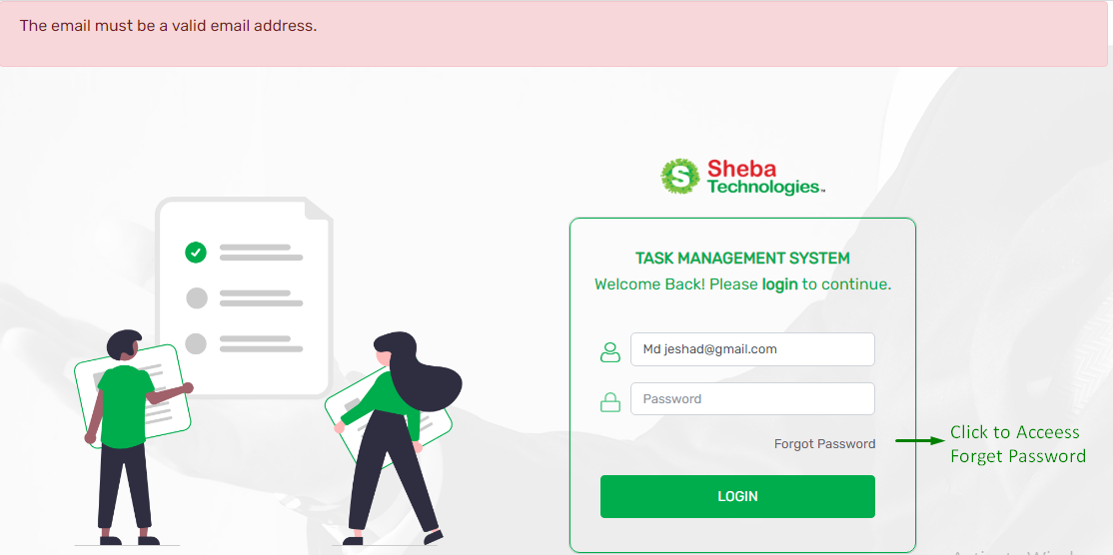If the user enters invalid email or password then the system will show unauthorized access to the user.

Figure 2 Invalid Login

### Forget Password

Figure 3 Reset Password Page

* Clicking on Forget password button will redirect to reset password page.
* Here user have to enter relevant user Email Address of the user.
* By clicking on Send Password Reset link button, user will get a password reset link in their given email address

# Navigation Bar

* From the Navigation Function Users will be able to access Dashboard, Task, Team Management, User Management, Role Management, New Task, New Team and Time & Date Features.
* Permission of the Navigation is limited depending on the access control of the User.

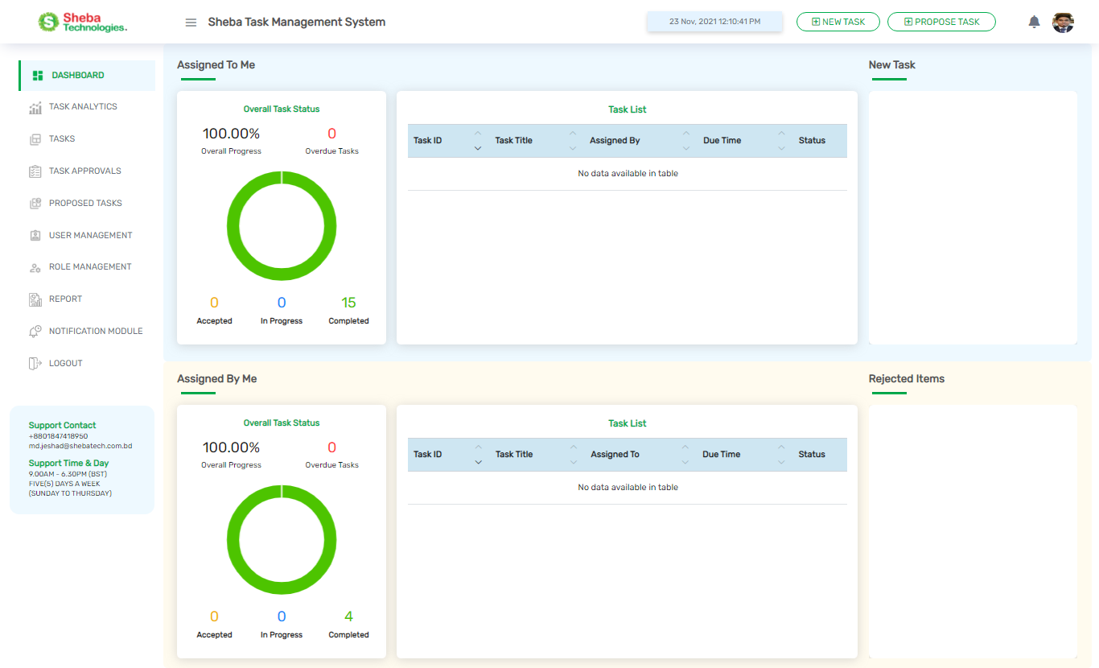

**Click**

**To Access Proposed Task page**

**Click To Logout**

**Click To Access**

**Notification Module**

**Click To Access**

**Report Generate**

**Click To Create New Task**

**Click to**

**Access Role Management**

**Click To Access Task Approvals**

**Click To Access Task**

**Click To Access Task Analytics**

**Click To**

**Access Proposed Task**

Figure 4 Navigation Bar

**Click To Access User**

**Management**

Table 2 Navigation bar details

|  |  |
| --- | --- |
| **Field Name/Button** | **Description** |
| **Dashboard** | Clicking on the button will redirect user to Dashboard Page. |
| **Task Analytics** | Clicking on the button will redirect user to Overall Task Status Page. |
| **Task** | Clicking the button will redirect user to All Task List Page. |
| **Task Approvals** | Clicking on the button ,user will redirect to All Proposed task list page |
| **User Management** | Clicking the button will redirect user to All User List Page. |
| **Role Management** | Clicking the button will redirect user to All Role List Page. |
| **Logout** | Prompt the user to logout and redirect user to Login Page. |
| **Report** | Clicking on the button user will be redirect to Report generate Page. |
| **Propose Task Button** | Clicking on the button, user will be redirected to Proposed Task Page. |
| **Notification Module** | Clicking the button will redirect user to All Event List Page |

## Propose Task

* 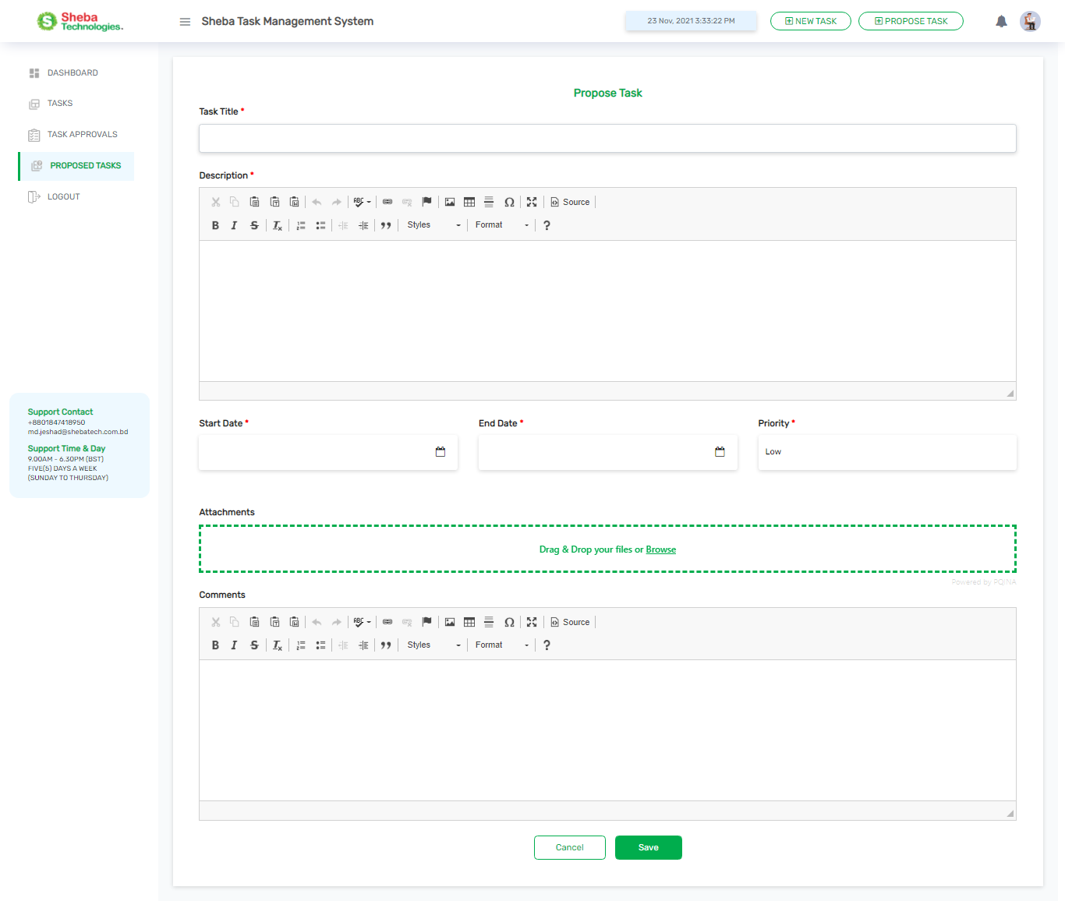Clicking on the Proposed Task button user will redirect to proposed task form.

|  |  |
| --- | --- |
| **Column/Field Name/Button** | **Description** |
| **Task Title** | User can click the task that are assigned to the user, to view the task detail |
| **Description** | Name of the respective user who assigned the task |
| **Start Date / End Date** | User can click the task that are assigned by the user, to view the task detail |
| **Priority** | Name of the respective user who will assigned for the task |
| **Attachments** | Relevant Id of Task |
| **Task Title** | Title of the Task |
| **Due Time** | Due date / time of the task |
| **Status** | Status of the relevant task |
| **Cancel** | User can click the task in the new task, to accept or reject the task |
| **Save** | User can click the task from the rejected items, to reassign rejected task to other user or accept requests |

# Dashboard

The Dashboard is divided into two section, which are as follows:

* **Assigned To Me**

1. Overall Task Status: View the status of the task that are assigned to the user.
2. Task List: View the task information which are assigned to the user.
3. New Task: New task that are requested to the user.

* **Assigned By Me**

1. Overall Task Status: View the overall status of the task that are assigned by the user.
2. Task List: View the task information which are assigned by the user.
3. Rejected Items: Displays assigned task which are rejected and requested by assignee users.

* **New Task View Card**
* **Rejected Items View Card**

Figure 5 User Dashboard

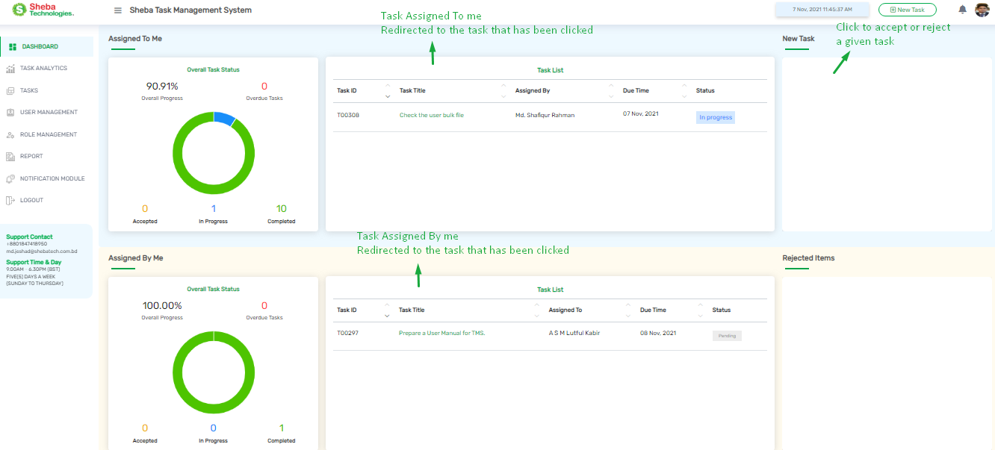

Table 3 User Dashboard Page Details

|  |  |
| --- | --- |
| **Column/Field Name/Button** | **Description** |
| **Task Assigned To Me** | User can click the task that are assigned to the user, to view the task detail |
| **Assigned by** | Name of the respective user who assigned the task |
| **Task Assigned By Me** | User can click the task that are assigned by the user, to view the task detail |
| **Assigned To** | Name of the respective user who will assigned for the task |
| **Task ID** | Relevant Id of Task |
| **Task Title** | Title of the Task |
| **Due Time** | Due date / time of the task |
| **Status** | Status of the relevant task |
| **New Task (View Card)** | User can click the task in the new task, to accept or reject the task |
| **Rejected Items (View Card)** | User can click the task from the rejected items, to reassign rejected task to other user or accept requests |

## Assign New Task

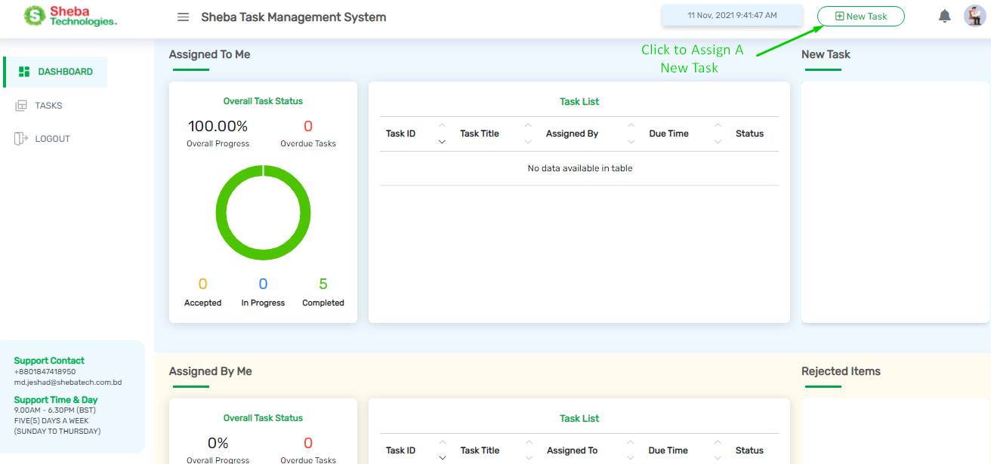

Figure 6 Assign a New Task

* Clicking on the New Task button user will redirect to Create New Task page.
* Here user will find a form for assigning a task to a designated person

### Create New Task (Assigner Module)

Figure 7 Create New Task Form

* Here user will find few fields, buttons Description box.
* Clicking on Save button will assign a new task.
* Clicking on Cancel button will close the form

Table 4 Create New Task Form details

|  |  |
| --- | --- |
| **Field Name/Button** | **Description** |
| **Task Title** | Title of the relevant task. |
| **Description box** | Enter description for the relevant. |
| **Assign To Individual** | Here search with the keywords and put check mark on the check box, and assign the task to a relevant assignee. |
| **Start Date** | Select relevant start date for the task. |
| **End date** | Select relevant end date for the task |
| **Priority** | Select priority level (High / Medium / Low) from the dropdown menu |
| **Attachments** | By clicking on Attachments button user will be able to attach relevant file and documents for the task. |
| **Comments** | Enter relevant comments for the task |
|  | By clicking on the button user will be able to assign a new task |
|  | By clicking on the button user will be able to close the Create New Task form |

* 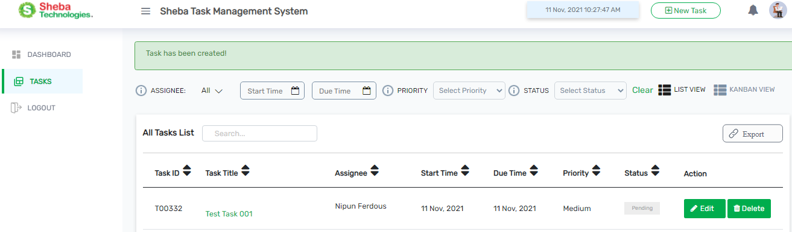After assigning a task user will see a confirmation message (Task has been created) on the top of All Task List page

Figure 8 New Task Create

* Assignee will get a notification in the web application and also at their relevant email.
* Here user can Edit or Delete a assigned task from the Action column
* 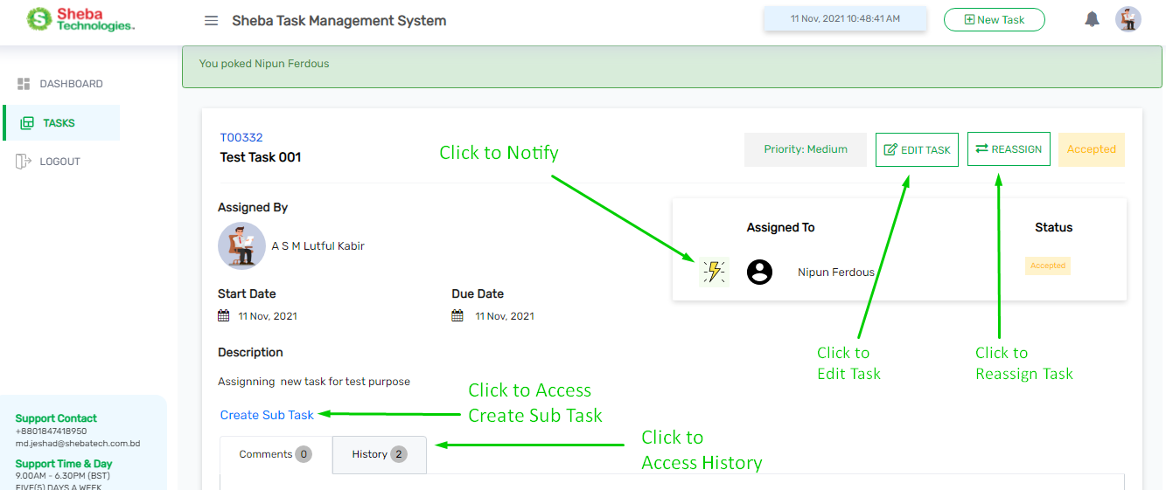Clicking on the relevant task from the All task list table, user will redirect to the Task Details page

Figure 9 New Task Details Page

* Here user can perform this following actions
* Edit task,
* Reassign task
* Notify the assignee (Nudge button)
* Acceptance status
* Create Sub Task of that task
* Comments / History about the task

Table 5 New Task Page Details

|  |  |
| --- | --- |
| **Field Name/Button** | **Description** |
| **Assigned By** | Name of the person who assigned the task. |
| **Assigned To** | Designated person for the task |
| **Status** | Acceptance status of the task. |
| **Edit Task** | Edit the relevant task. |
| **Reassign** | Reassign to task to another person. |
| **Description** | Description about the relevant task. |
| **Create Sub Task** | Clicking on this user will be able to create sub task. |
| **History** | Click to access history. |
| **Comments** | Here user can add comments in the task. |
| **Priority level** | Priority level of the relevant task |
| **Nudge Button** | Clicking on the button notify the designated person for the task. |

### Accept New Task (Assignee Module)

* 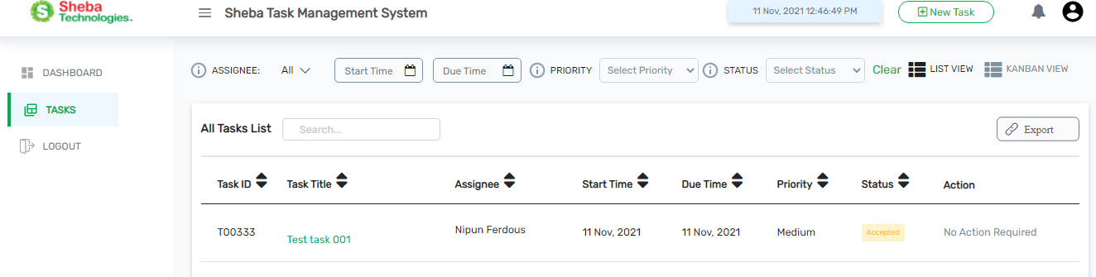User can see the assigned task from the Task menu, as well as from the dashboard.

Figure 10 All Task List (Assignee Module)

* Clicking on Accept or Reject button, user will be able to accept or reject a task.
* Clicking on relevant task user will redirect to details page of that task.

#### Update Task Status

* 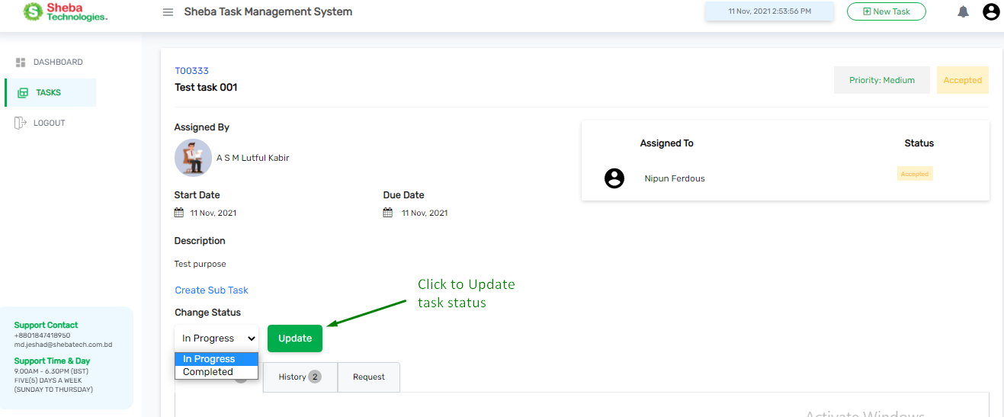In this page user will find all the details about the Task.

Figure 11 Update Task Status

* From Change Status drop down user can change the task status, then user have to click update button to update status of the task.
* User can add comments about a task, check history about the task.

#### Request In Task

* Clicking on request button user will be able be redirect to Request for menu
* Here user can request for leave, time extension etc.
* Clicking on Save button user will be able submit the request
* Clicking on Close button user will be able to close the form

Figure 12 Request Menu

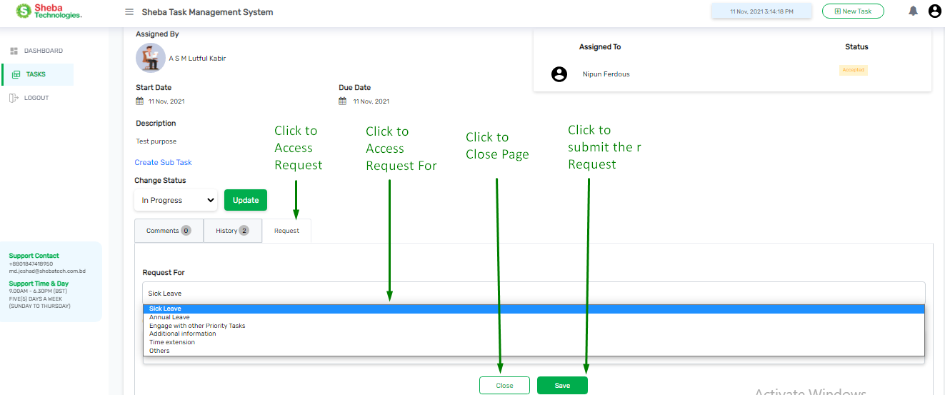

Table 6 Al Task List Page Details

|  |  |
| --- | --- |
| **Field Name/Icon/Button** | **Description** |
|  | Enables admin to search for any keyword; |
|  | User can go back and forth of pages by clicking Next/Previous buttons. |
|  | User can decide to view the number of entries of total skills from this drop down list at the bottom left corner of this page. |
|  | Click to generate report. |

# Task Analytics

Clicking on Task Analytics button user will redirected to Task analytics page

Here user will find following sections:

* Over All Task Status.
* Direct Supervisee Status.
* Program Wise Details
  + - Overdue Task Status
    - Overall Task Status
    - Programme Task Details
    - Individual Task Details

## Overall Task Status

Figure 13 Overall Task Status Panel

* 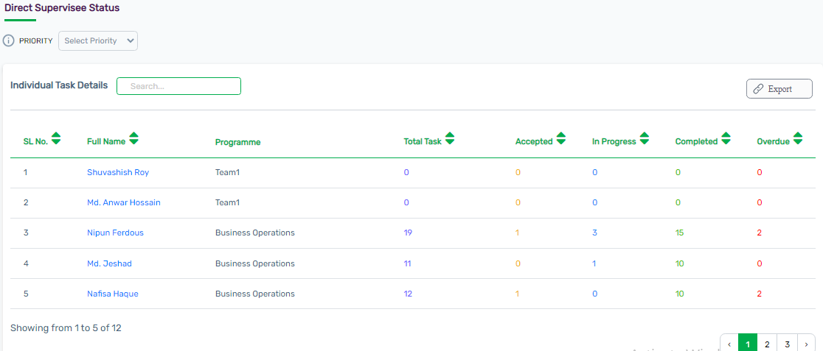Here user will find all statistics related to the task that are assigned accepted, In Progress, completed rejected, overdue.

Figure 14 Individual Task Details

* Here user will find the designated Supervisee status of that user.
* Assigned task details of the Supervisee.

## Program Wise Details

Figure 15 Program Wise Details

* Here user will find program wise details of the supervisee.

### Overdue Task Status

Figure 16 Overdue Task Statistics

* Here user will find the name wise statistical chart of Overdue Task Status.

### Overall Task Status

Figure 17 Statistics of Overall Task

### Programme Task Details

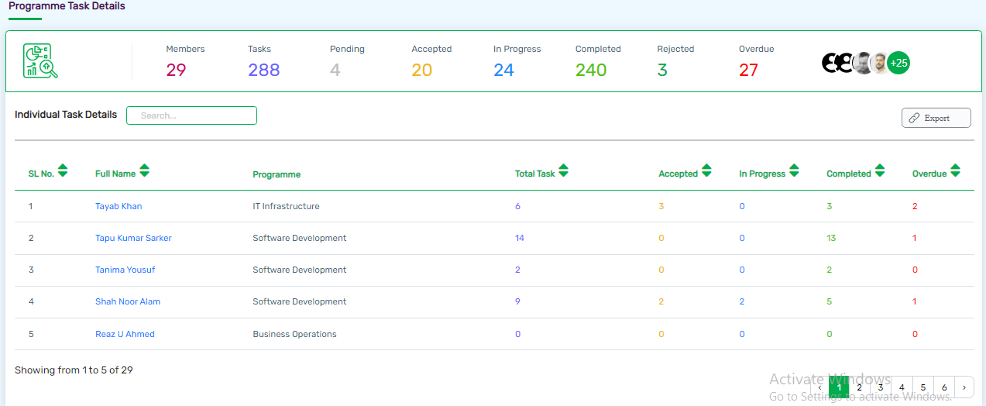

Figure 18 Programme Task Details

* Here user will find statistical details of Programme Task Details.
* Relevant Individual Task Details, Search box, Report generate etc.

# Tasks

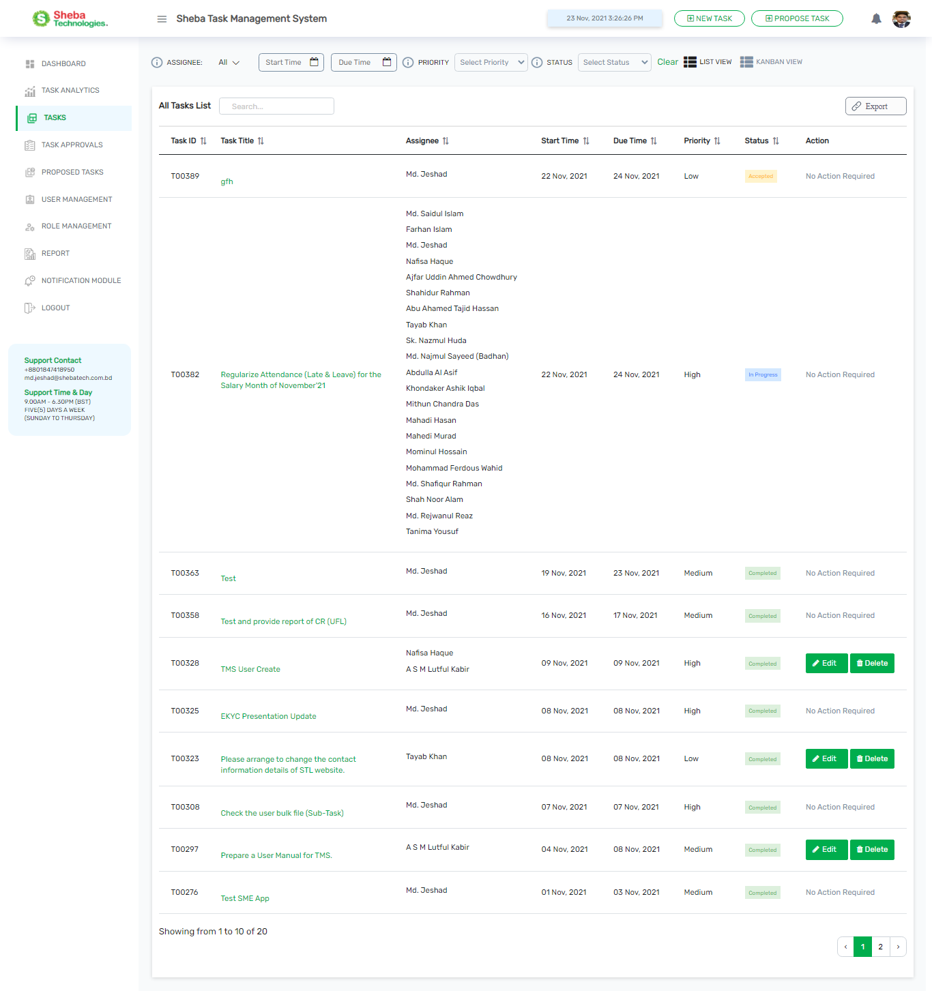

# Task Approvals

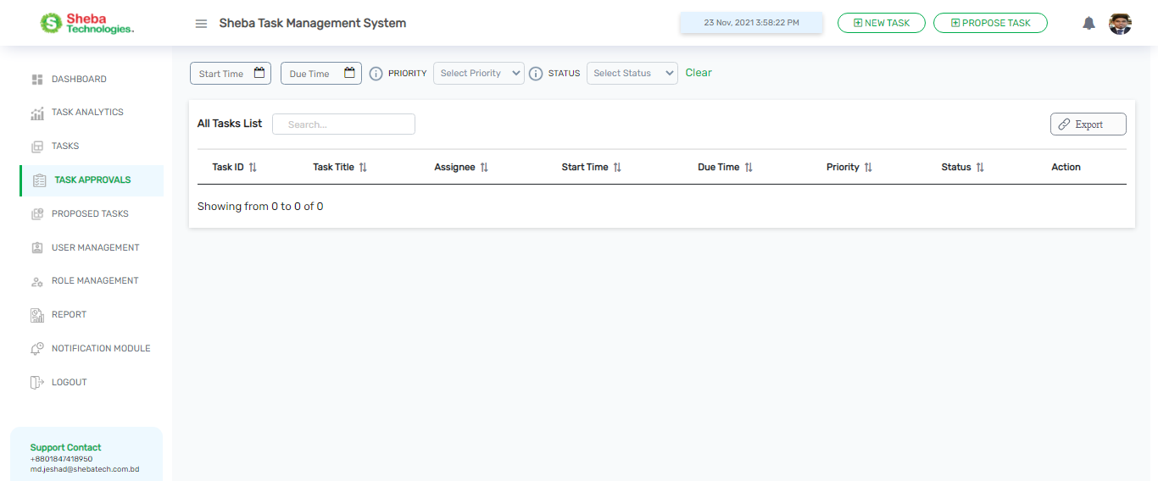

# Proposed Tasks

Clicking on the Proposed Task Button will redirected Proposed Tasks page.

# User Management

* Clicking on User management from the navigation bar , admin will be redirected All User List Page

## All User List

Figure 19All User list (1)

* The user management feature will allow the Admin to create and modify user roles for the system.
* By Clicking on Export (PDF) button, Admin will be able to download all user list details report.
* By Clicking on Edit button, enables admin to modify the specific user information.
* By Clicking on New User button, allows admin to create or register new user.
* 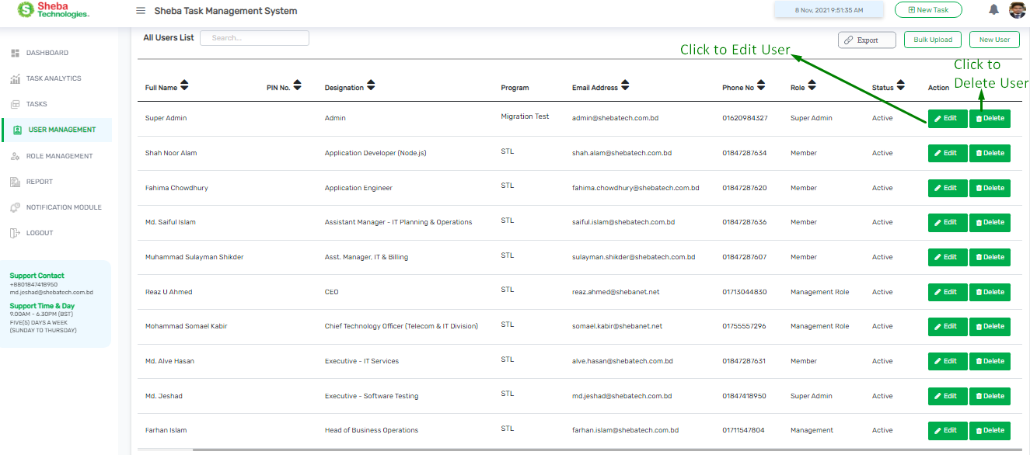By Clicking on Bulk Upload button, enables admin to register user through bulk format.

Figure 20 All User List (2)

Table 7 All User list Table details

|  |  |
| --- | --- |
| **Column / Field Name /Button** | **Description** |
| **New User** | By clicking on the button admin will be able to create or register new user |
| **Edit / Delete** | Modify the specific User/Delete a specific user |
| **Bulk Upload** | Upload bulk file to register User |
| **Export (PDF)** | Generate report of All User List |
| **Full Name** | Name of the User |
| **Designation** | Designation of the relevant user |
| **Program** | Relevant Program name of the user |
| **Email Address** | Email address of the user |
| **Phone No** | Relevant phone no of the user |
| **Status** | Active or Inactive status of the user |
| **Action** | Click to Edit information of the user , Click to Delete the user |

## Add New User

* 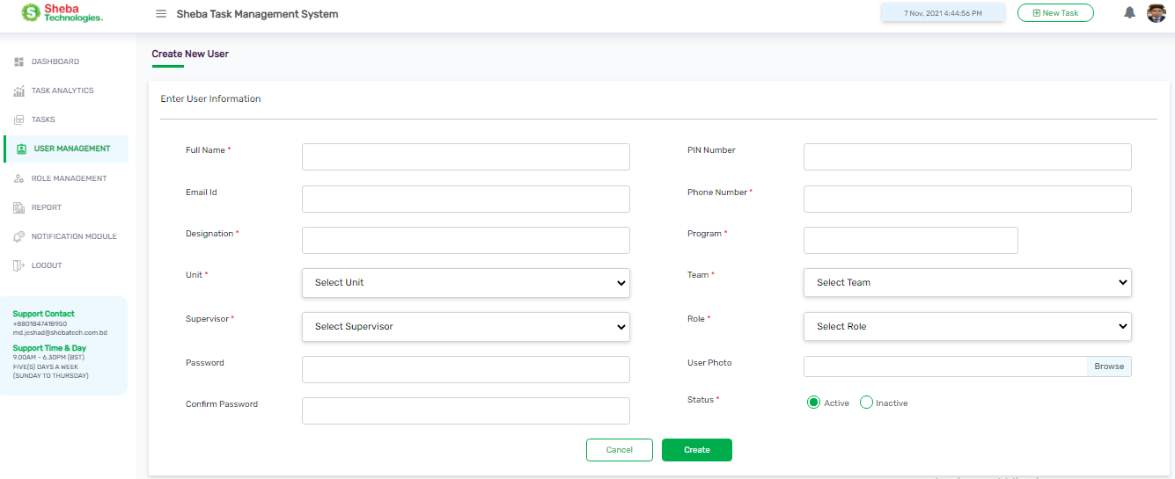Clicking on New User button Admin will redirect to Create New User Page

Figure 21 Create New User Page

* Adding new user will require user’s full name, designation, email address, PIN, password, role unit, supervisor, team, program, phone number and user photo.
* The super admin can then select a role for a new user for specific role and can determine Activity Status as well;

|  |  |
| --- | --- |
| **Field Name/Button** | **Description** |
| **Full Name** | Enter user full name |
| **Designation** | Enter user designation |
| **PIN Number** | Assign a PIN for the user |
| **Email** | Enter user email address |
| **Phone Number** | Enter user phone number |
| **Password** | Enter a password for user |
| **Confirm Password** | Enter same password to confirm |
| **Role** | Select Role from role data |
| **Unit** | Select Unit from unit data |
| **Supervisor** | Select Supervisor from supervisor data |
| **Team** | Select Team from team data |
| **Program** | Select Program from program data |
| **User Photo** | Browse and upload user photo |
| **Create** | Clicking on the button will create new user |
| **Cancel** | Clicking on the button will close the form. |

Table 8 Create New User Page Details

## Edit User

* Clicking on Edit button from the action column will redirect to Edit User Page;
* Editing a user will give the ability to change user’s full name, designation, email address, PIN, password, role unit, supervisor, team, program, and phone number and user photo.
* 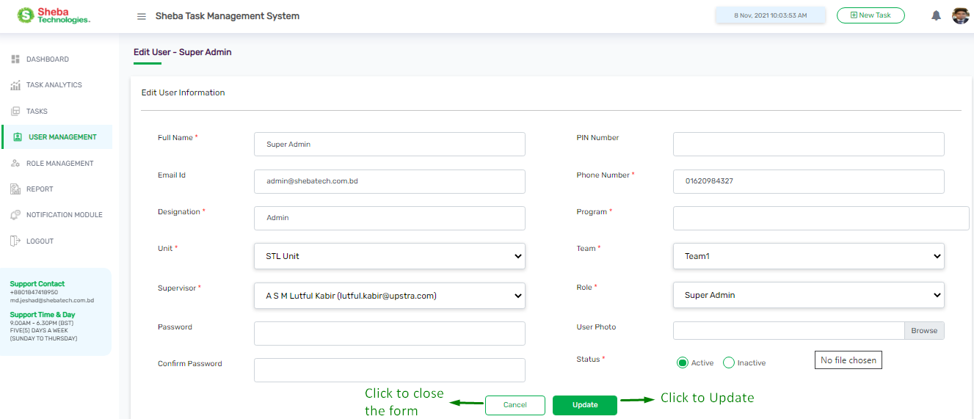The super admin can then change a role for a new user for specific role and can determine Activity Status as well.

Figure 22 Edit User Page

Table 9 Edit User Page Details

|  |  |
| --- | --- |
| **Field Name/Button** | **Description** |
| **Full Name** | Enter user full name |
| **Designation** | Enter user designation |
| **PIN Number** | Assign a PIN for the user |
| **Email** | Enter user email address |
| **Password** | Enter a password for user |
| **Confirm Password** | Enter same password to confirm |
| **Role** | Select Role from role data |
| **Unit** | Select Unit from unit data |
| **Supervisor** | Select Supervisor from supervisor data |
| **Team** | Select Team from team data |
| **Program** | Select Program from program data |
| **Phone Number** | Enter user phone number |
| **User Photo** | Browse and upload user photo |

## Bulk Upload

* 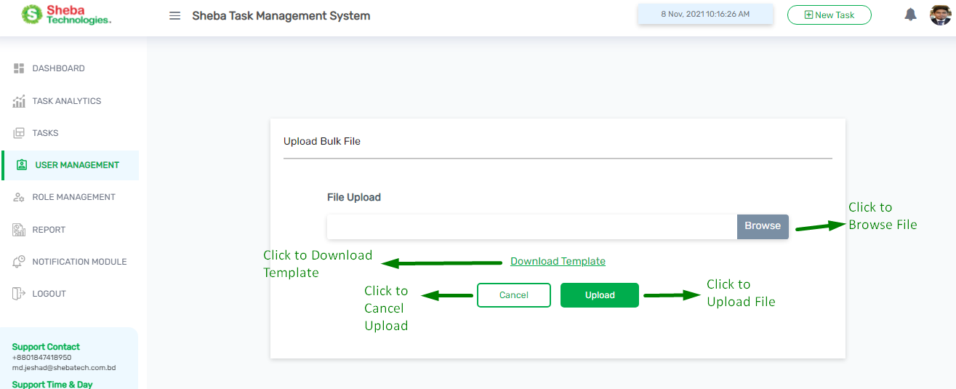Clicking on Bulk Upload button from the User Management Page will redirect to Upload Bulk File Page

Figure 23 Bulk Upload Page

* Admin will be able to upload list of users by use of Bulk Upload. The format is being clarified in the Template

Table 10 Bulk Upload Page Details

|  |  |
| --- | --- |
| **Field Name/Button** | **Description** |
| **Browse** | By clicking on the button user can browse and select file from the local device and upload the file. |
| **Download Template** | By clicking on the button user can download the format of the Bulk file |
| **Update** | Click to update a new users into the user list. |
| **Cancel** | Click cancel to close. |

# Role Management

* Clicking on Role Management Function Admin will redirect to All Role List page.
* 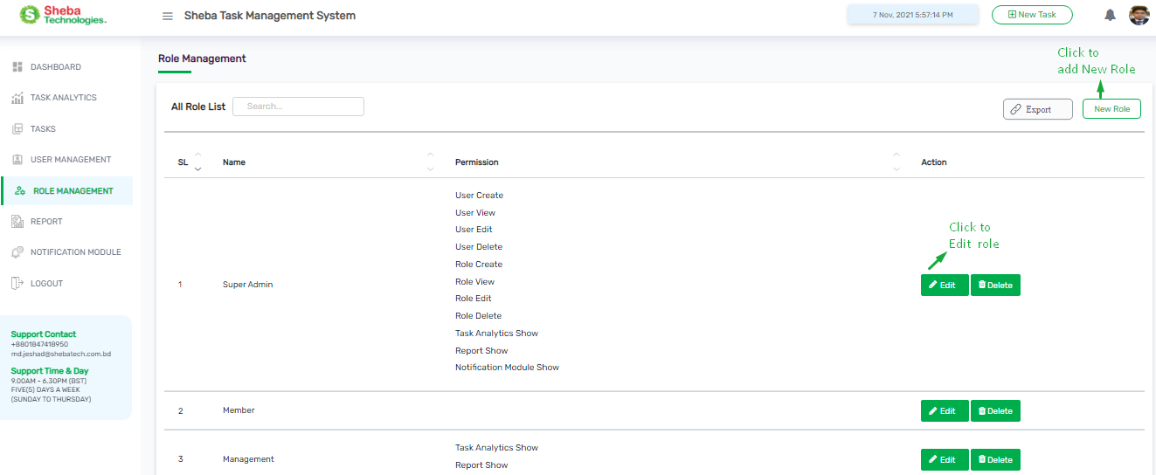Here admin will find Create Role and Edit Role Features.

Figure 24 Role Management Page

## All Role List

* Role List will provide the details of the roles and permission, along with features such as Creating Role, Editing, Deleting and Exporting

Table 11 Role Management Page Details

|  |  |
| --- | --- |
| **Column /Field Name/Button** | **Description** |
| **New User** | Create or register new Role |
| **Name** | Name of the role |
| **Permission** | Relevant Permission for the designated role |
| **Edit** | Modify the specific Role |
| **Delete** | Remove Role from Role List |
| **Export (PDF)** | Generate report of All Role List |

## Create Role

* 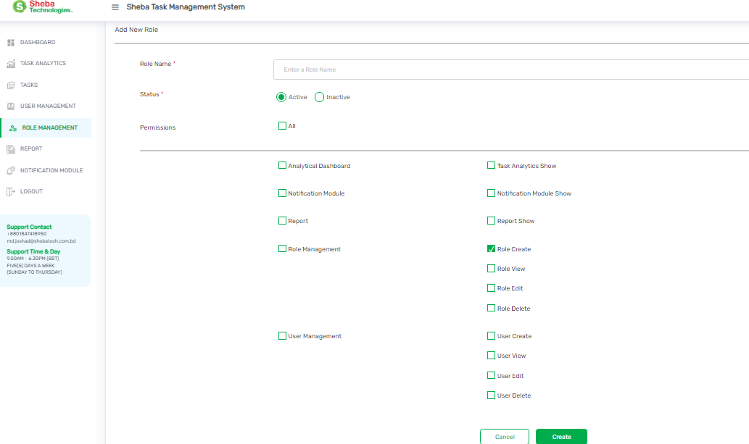Clicking on new role will redirect to Add New Role page

Figure 25 Add New Role Page

* Here user will find relevant information for adding a New Role into the system

Table 12 Add New Role Page details

|  |  |
| --- | --- |
| **Field Name/Button** | **Description** |
| **Role Name** | Enter Role Title |
| **Status** | Select Status between Active & Inactive |
| **Permission** | Select relevant Permission from Permission check box |
| **Create** | Click to create a new role into the role list. |
| **Cancel** | Click cancel to close. |

## Edit Role

Figure 26 Edit Role Page

* Edit Role will provide the user to change roles, permission and status
* Here user will find relevant information for edit a role

Table 13 Edit Role Page details

|  |  |
| --- | --- |
| **Field Name/Button** | **Description** |
| **Role Name** | Rewrite Role Title |
| **Status** | Change Status between Active & Inactive |
| **Permission** | Change Permission from Permission data |
| **Create** | Click to create a new role into the role list. |
| **Cancel** | Click cancel to close. |

# Report Generate

* Clicking on Report Button from the Navigation user will redirect to report generate page

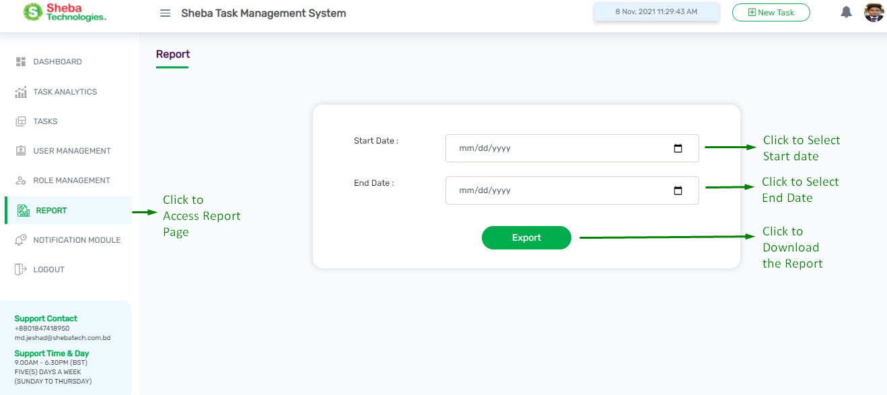

Figure 27 Report generate page

* Here User will find Start Date field and End Date Field, Export button.

Table 14 Report generate page details

|  |  |
| --- | --- |
| **Field Name/Button** | **Description** |
| **Start Date** | Relevant start date for the report |
| **End Date** | Relevant end date for the report |
| **Export** | Click to generate and download the report |

# C:\Users\Sheba\OneDrive\Documents\screencapture-tms-shebatech-bd-notification-module-2021-11-08-12_03_01.pngNotification Module

Figure 28 Notification Module page

* Clicking on Notification module from the navigation bar user will redirect to Notification Module’s All Event List page.
* Here user will find all events name, Email column In APP column, Export button, Update button, Search Box.

Table 15 Notification Page details

|  |  |
| --- | --- |
| **Column/Field Name/Button** | **Description** |
| **Events** | Name of the relevant Event. |
| **Email** | In this column user will find relevant check boxes for any respective event Check / Uncheck will allow that event to send notification via Email |
| **In App** | In this column user will find relevant check boxes for any respective event Check / Uncheck will allow that event to send notification In app |
|  | Clicking on Update button will confirm all relevant changes have been made |
|  | Using relevant keyword in the Search box user will be able to search any information |
|  | Clicking on Export button user will be able to generate relevant report |
| **Checkboxes** | User can check / uncheck boxes for any respective event |

*THANK YOU*